ELEC 5220/6220 Information Networks and Technology
LAB 9 REPORT

Jie ZOU
Xiao LIN

Abstract
This lab includes installing wireshark and using wireshark tool to capture the data sending from or to our computer through the internet.

Introduction
Wireshark is a free and open-source packet analyzer, which is used to analysis the network data and network troubleshooting. Original it is named Ethereal.

Design
First we install Wireshark downloaded from www.wireshark.org.
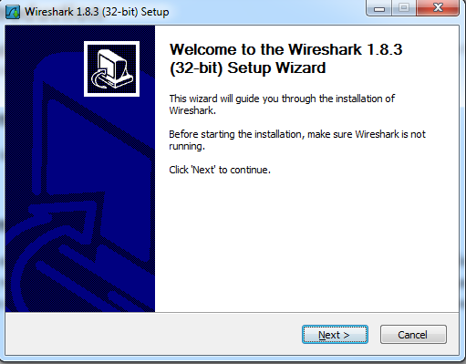
Figure 1 Installing Wireshark
After intalling it, we start Wireshark.
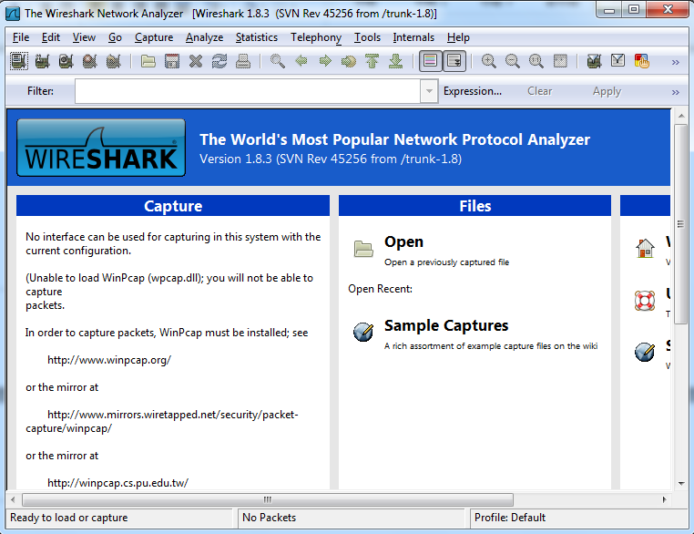
Figure 2 Wireshark software

Then we choose Interfaces to start capture.
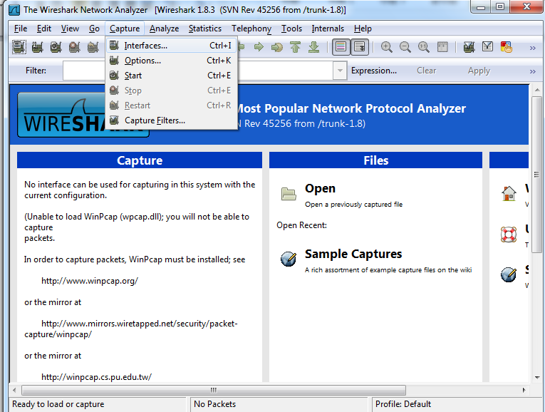
Figure 3 Choosing interfaces
Following screen shot shows the interfaces window.
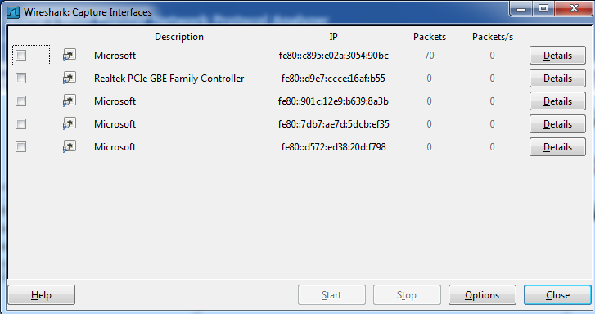
Figure 4 Interfaces window

Then we star the capture by clicking the start button.
We start a web browser and enter a URL such as www.apple.com.
Then we click the stop botton and use expression.
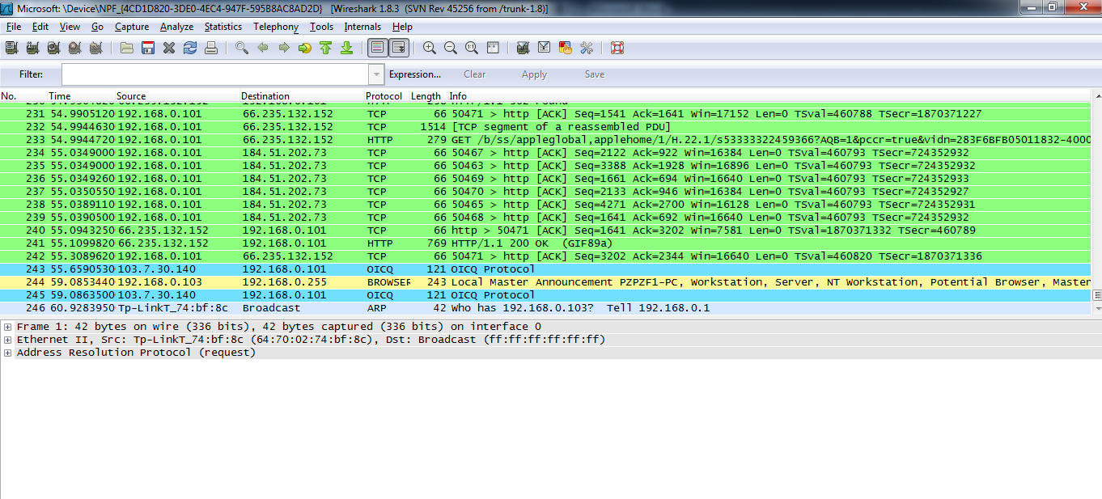
Figure 5 Clicking the stop button.
We use expression and expand IP by click the +
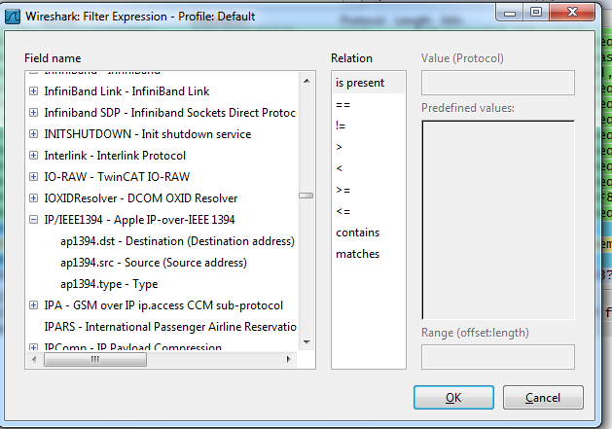
Figure 6 Using expression

Use destination address and use cmd to get apple.com’s IP address.
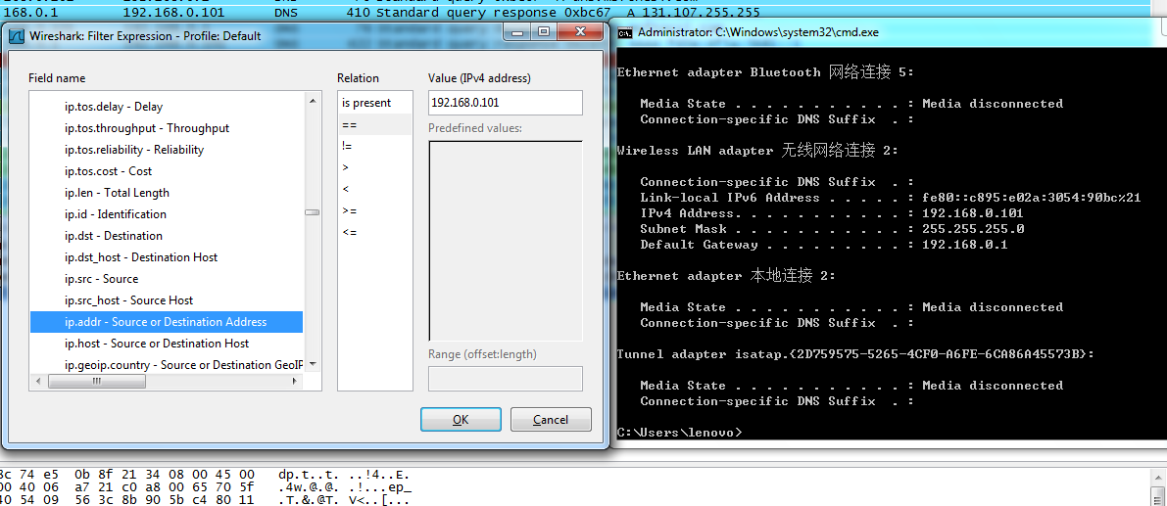
Figure 7 Using expression to limit the IP address

We click apply.
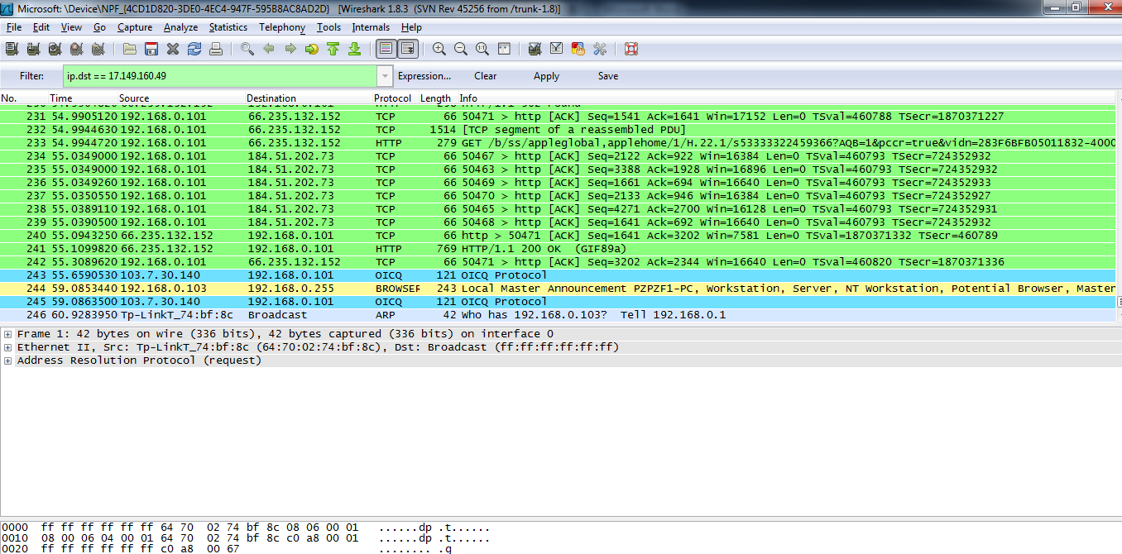
Figure 8 Clicking apply

The following screen shot shows how the connection to be established. Notice the first line of SYN and the last two of SYN ACK and SYN.
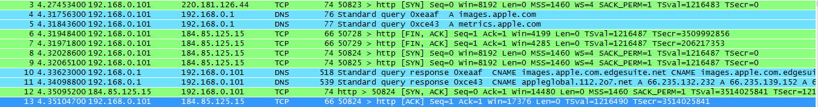
Figure 9 Three way handshake

Next screen shot shows the termination using FIN.
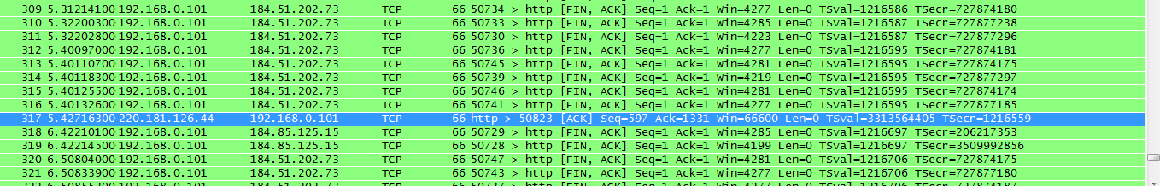
Figure 10 Termination

Following screen shot shows requiring images
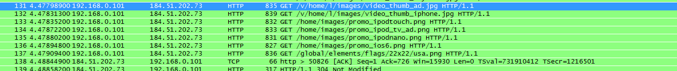
Figure 11 Require images

The following screen shot shows first I require ACK=1 and my seq=1
Next the server send the package.
After I received, I send Seq=638 and ACK=2897, which means I required package of 2897. The flags are ACK.
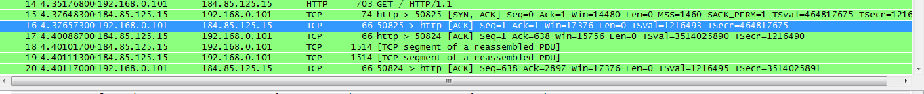
Figure 12 Seq number and ACK number relationship

Then we are require to see the difference between GET and POST method in Lab 2. The following screen shot show the result.
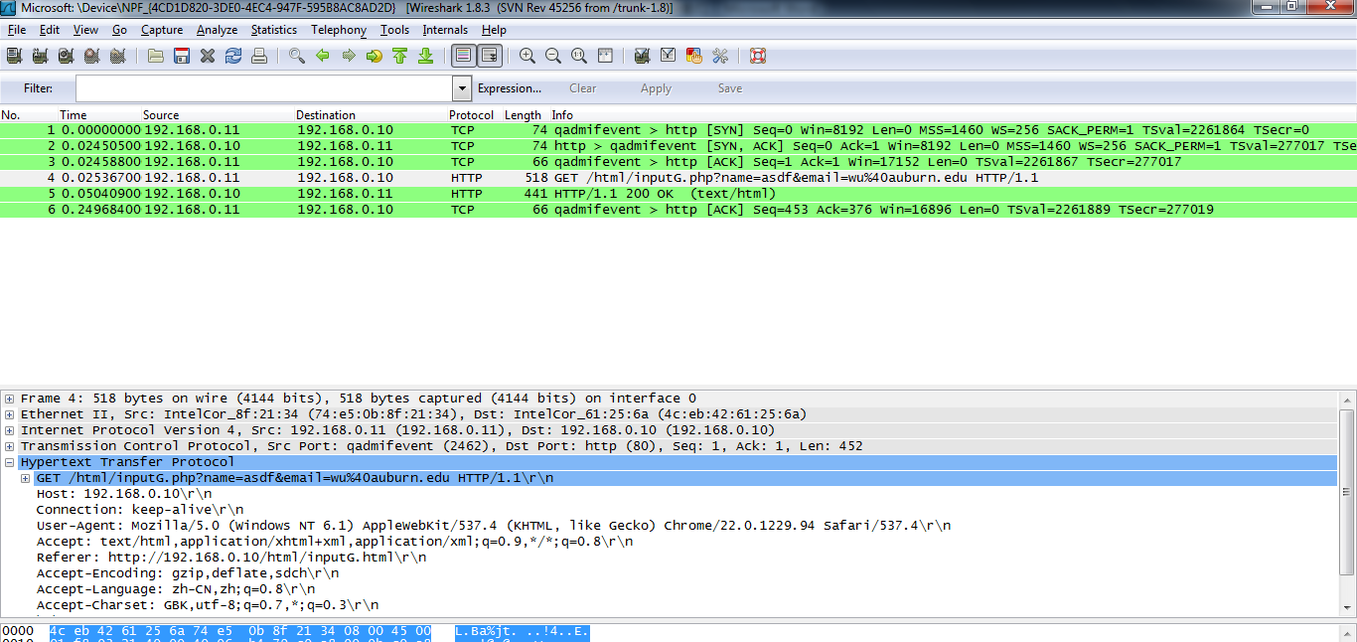
Figure 13 GET method with the request in the package
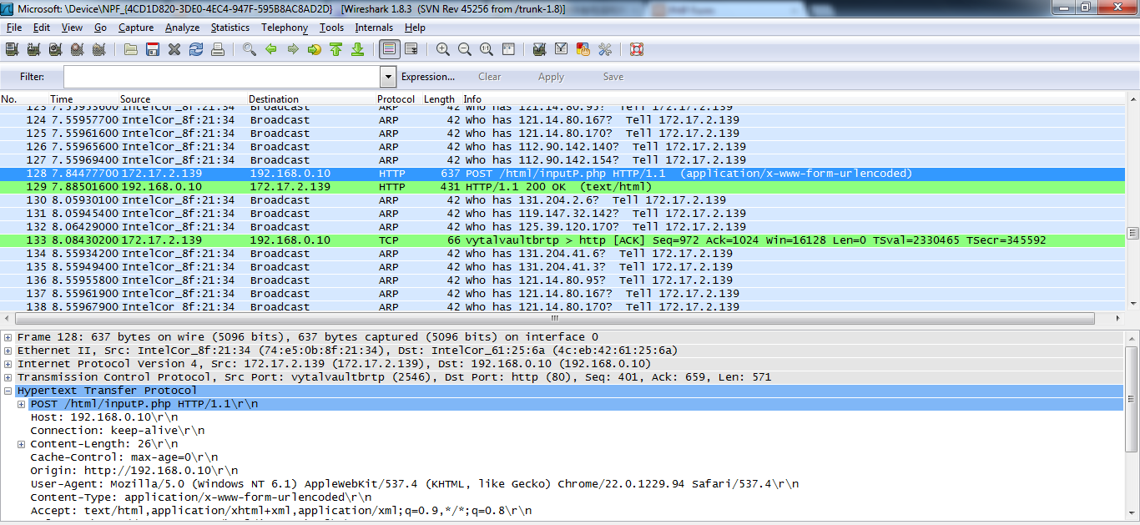
Figure 14 Post method without the request in the package

Next we run Lab 6 with the AJAX Get method.
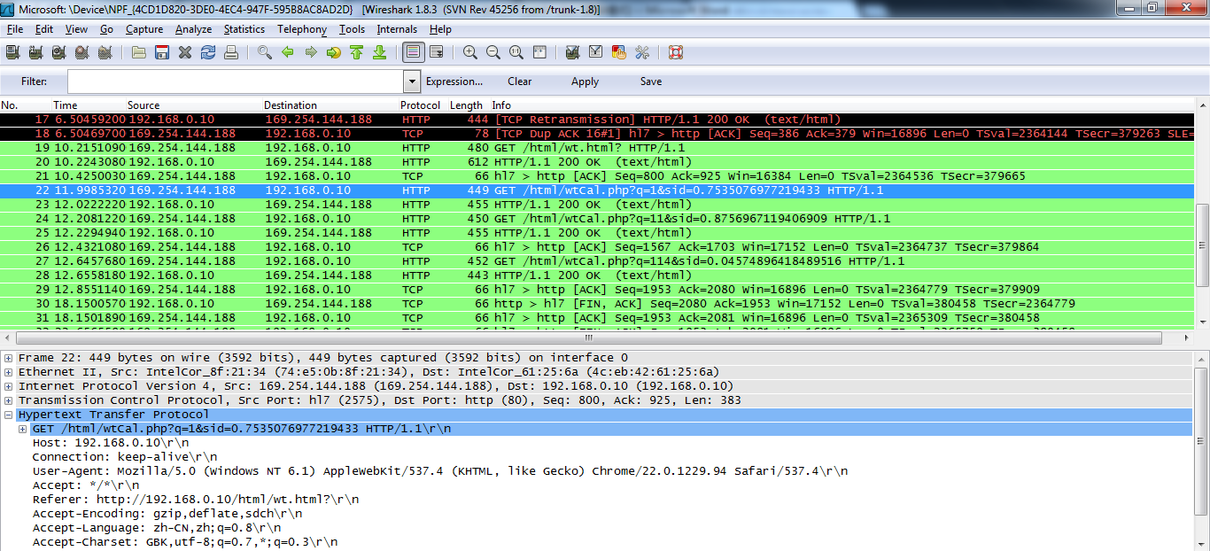
Figure 15 When enter “1” in the blank
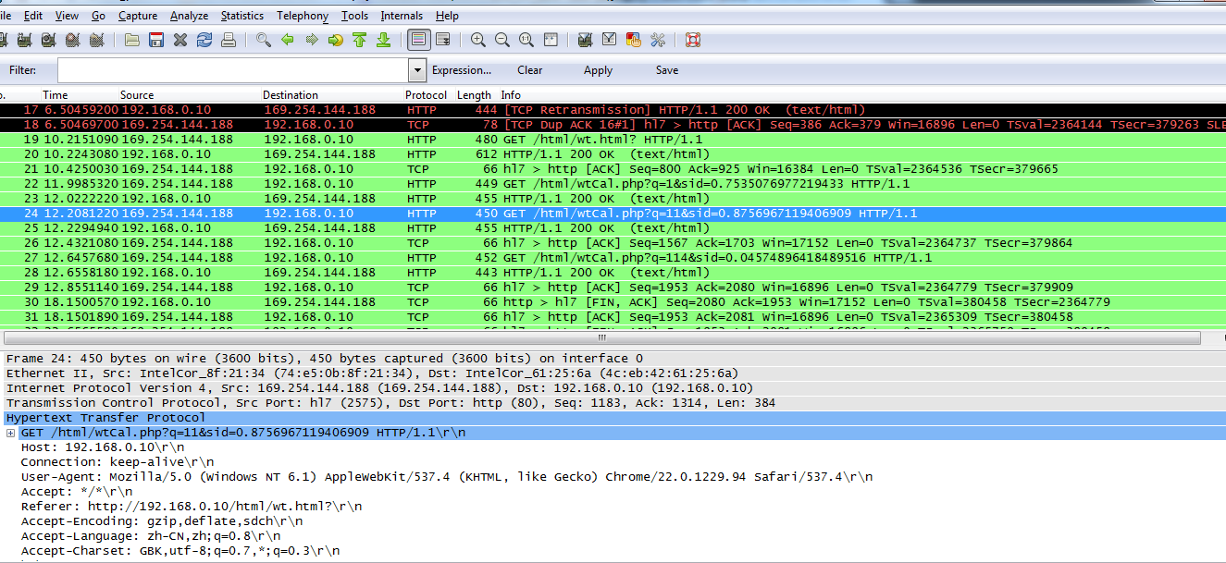
Figure 16 When enter “11” in the blank
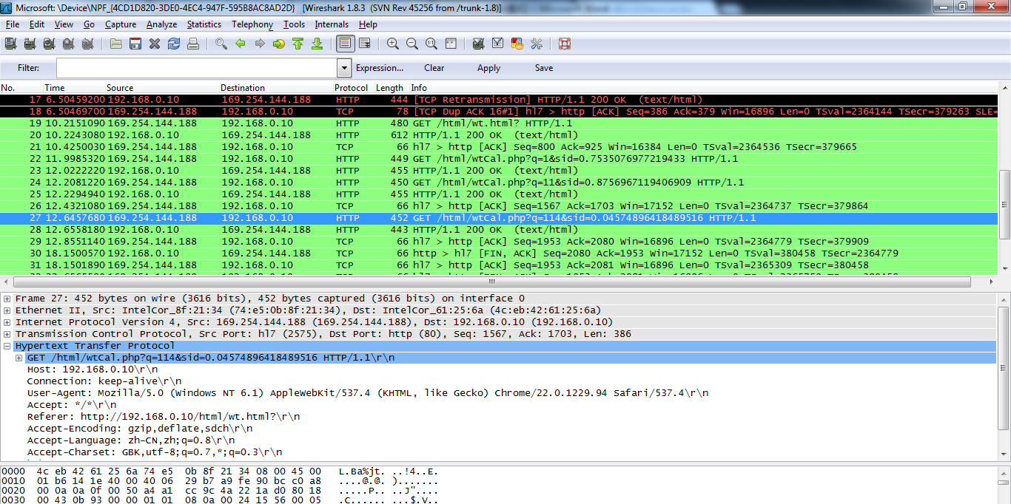
Figure 16 When enter “114” in the blank
It shows that when I entering 114 in the blank, the html will send a GET package of each number I entered in the blank.

Next we are going to anlys FTP. The following screen shot show 3-way handshake.
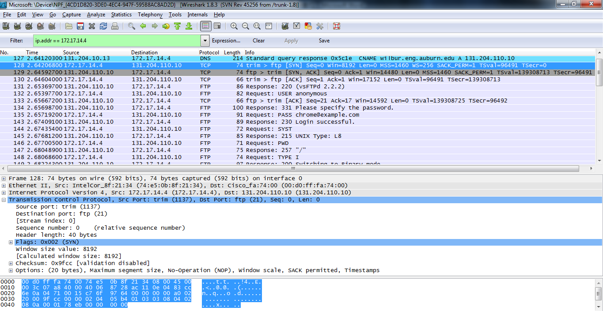
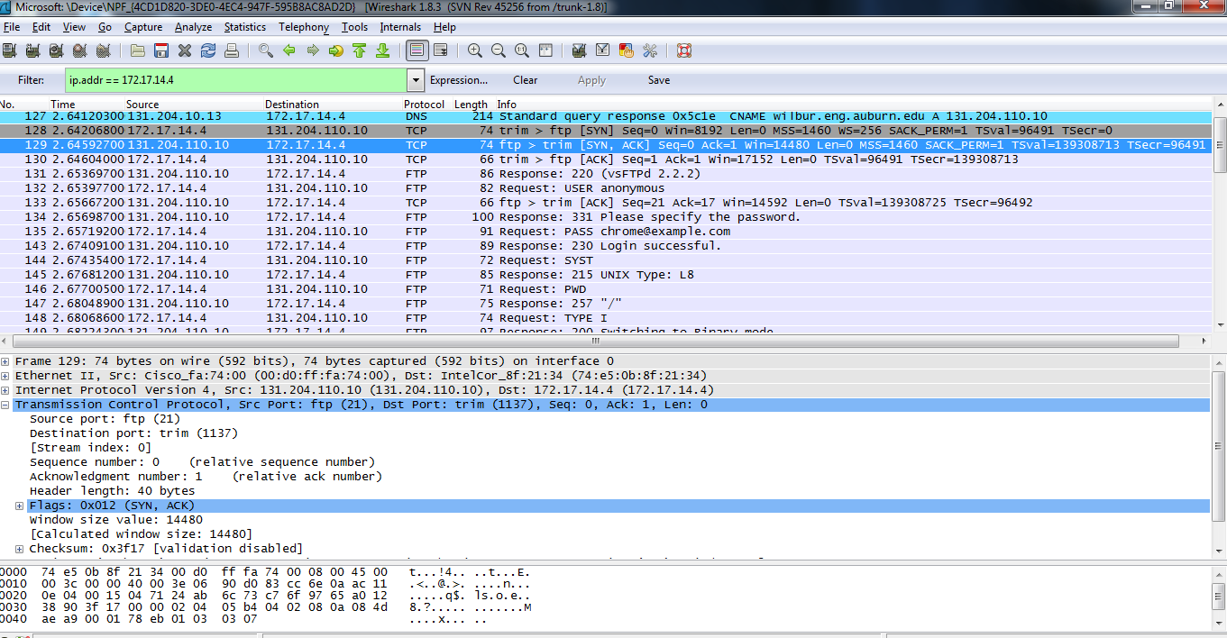
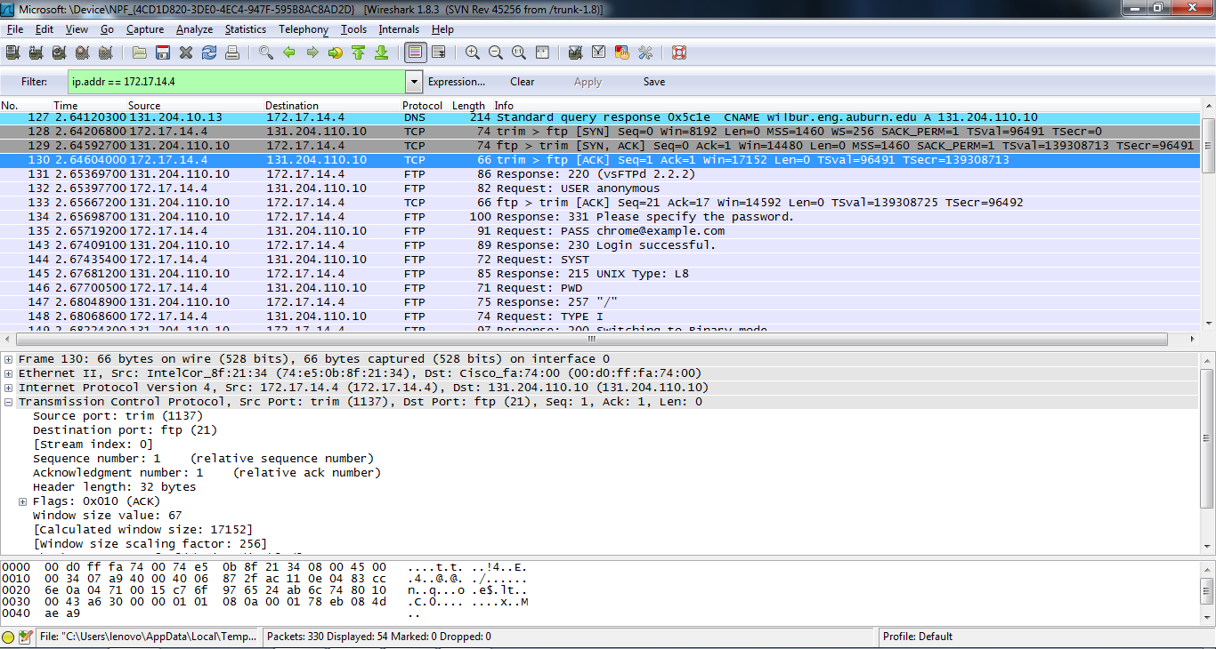

The following screen shot shows closing connection.
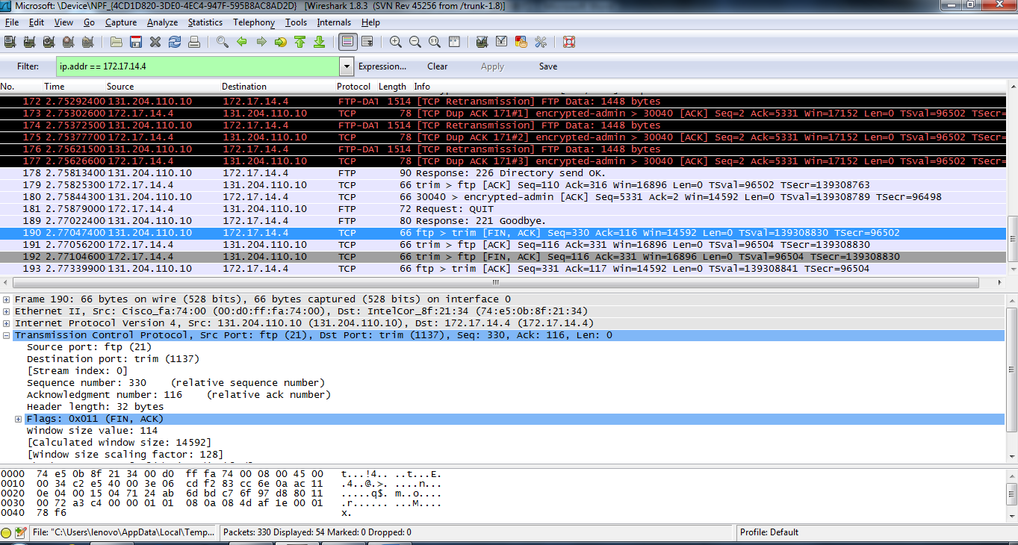
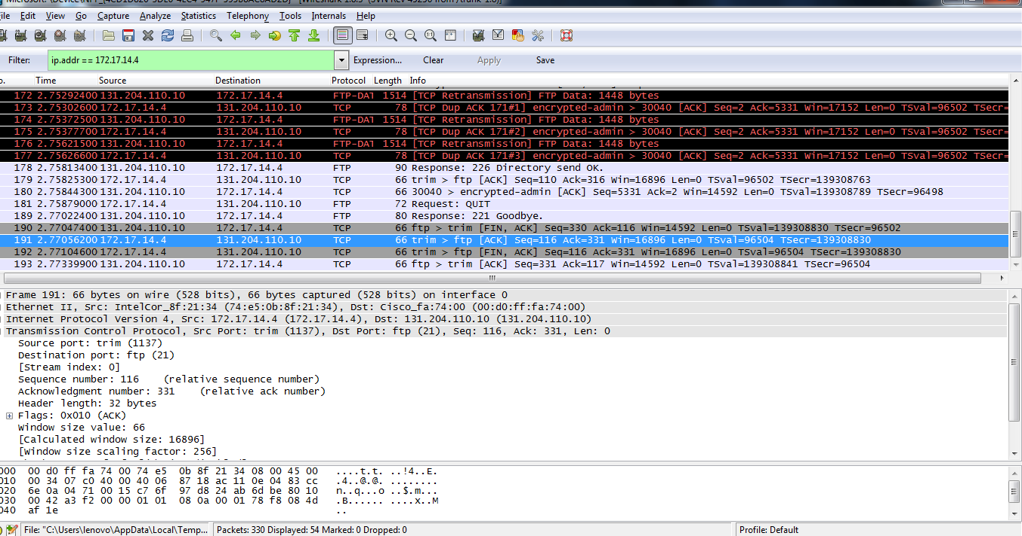
The following screen shot shows sniffing password.
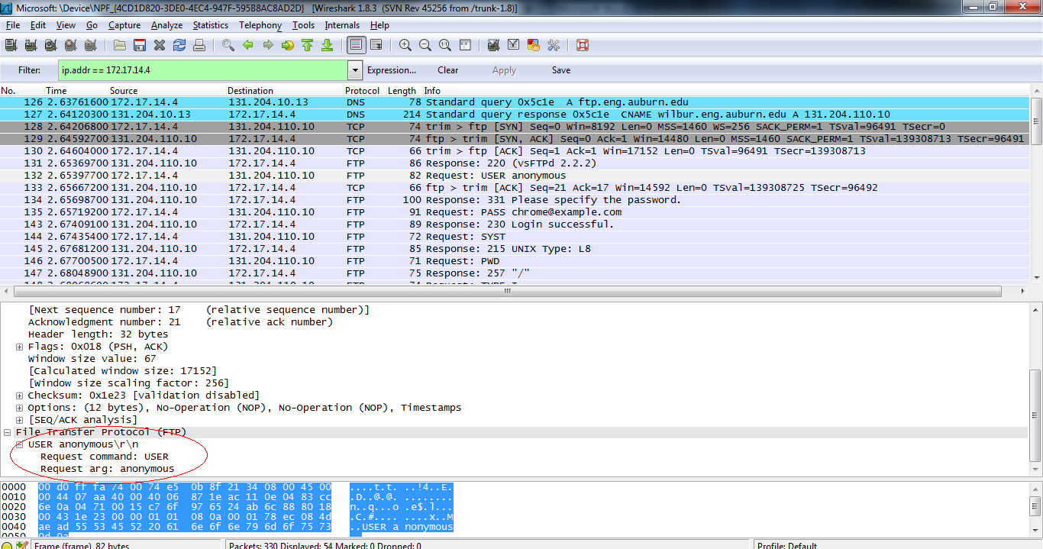

Next we are going to use Nmap after we install it.
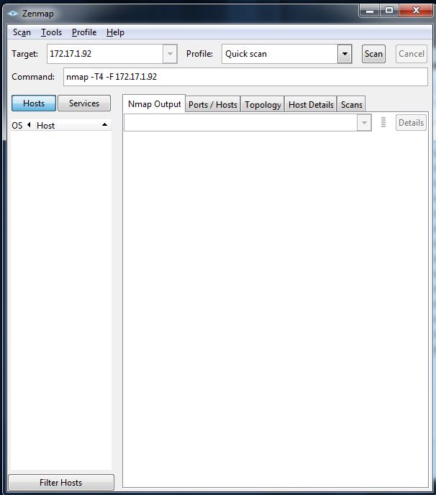
Figure Starting Nmap
Then we click scan.
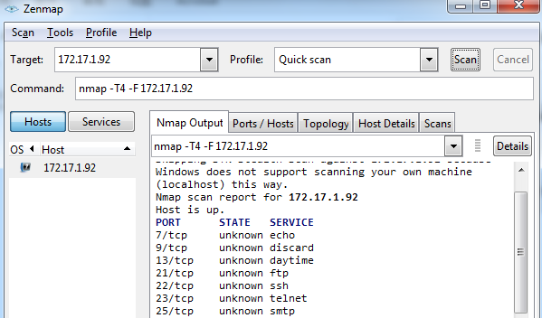
Figure Show the open ports
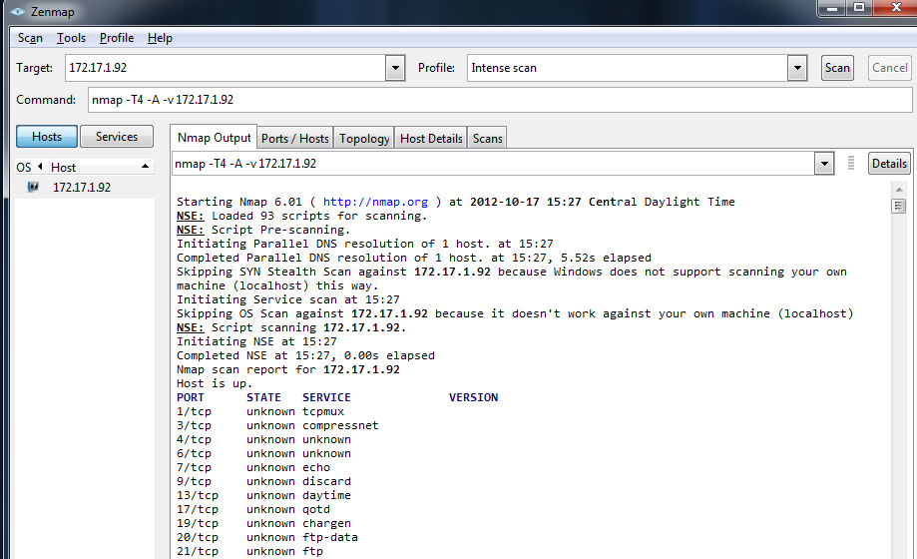
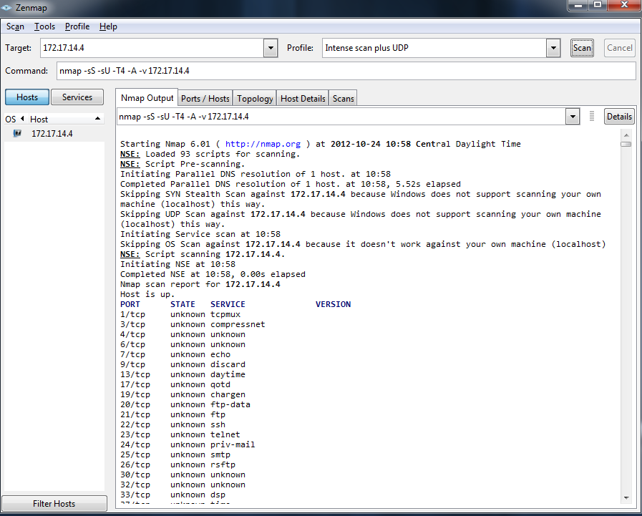
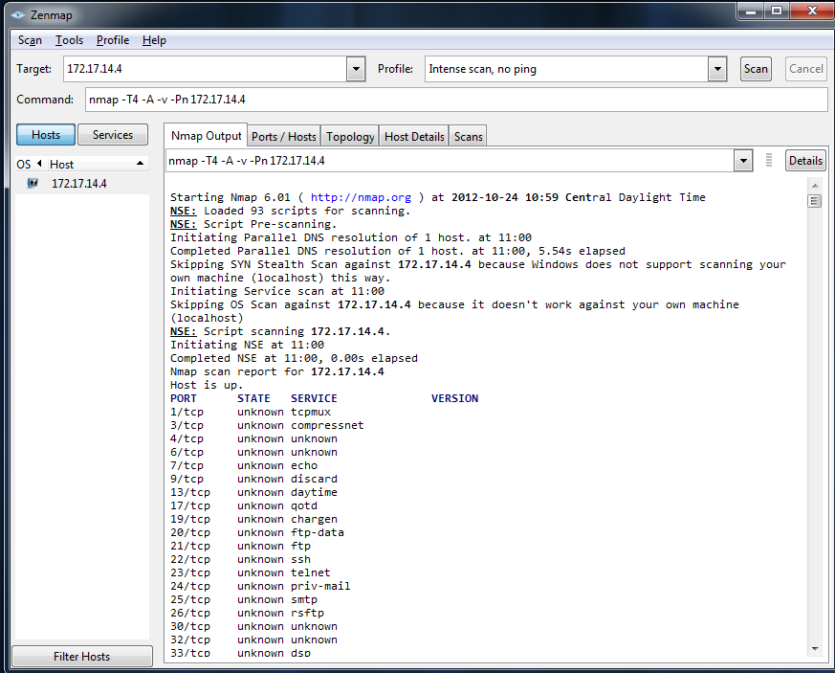
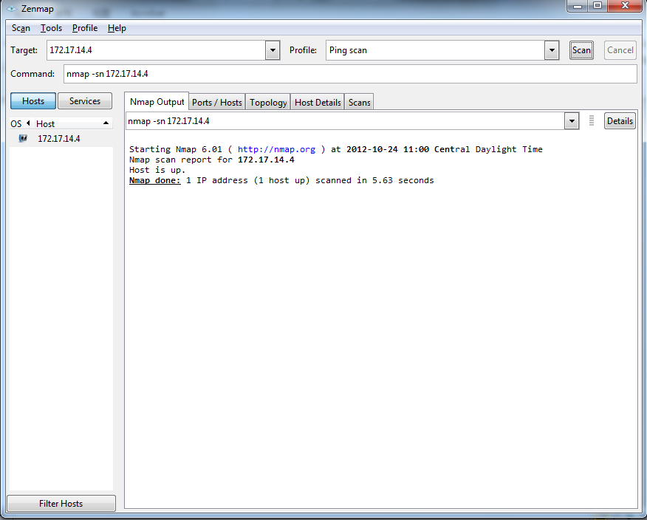
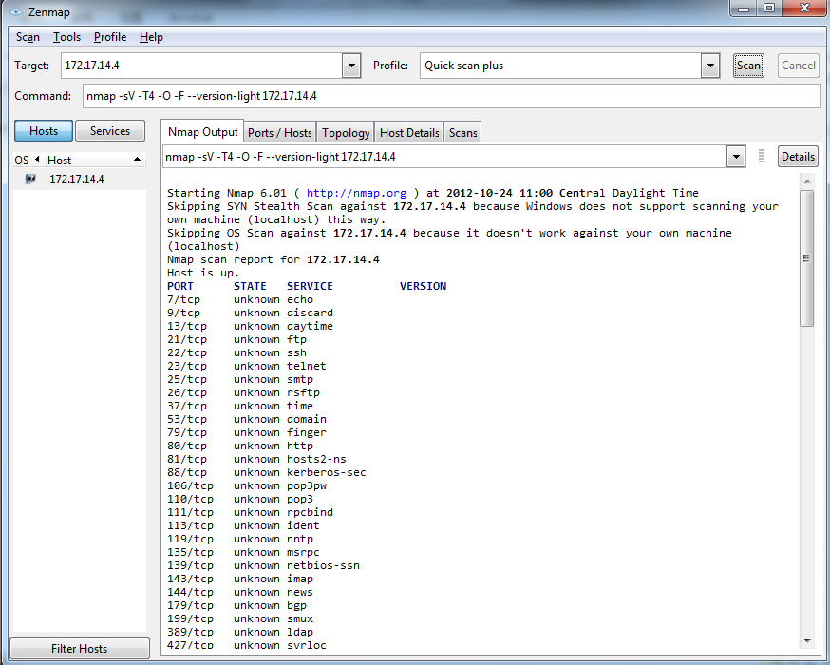
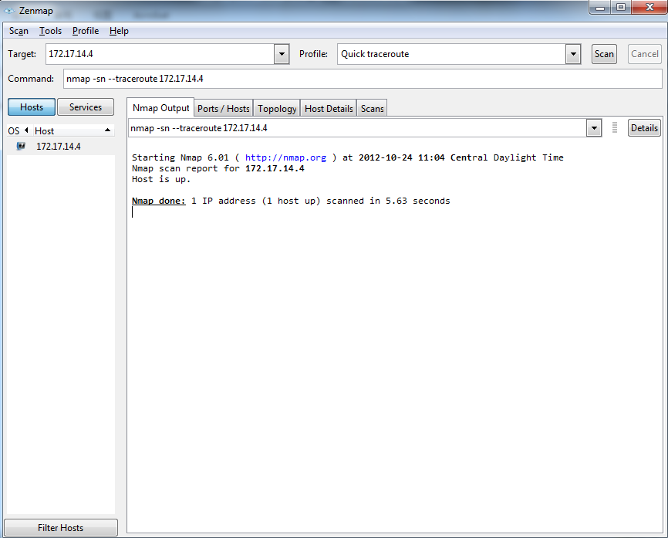
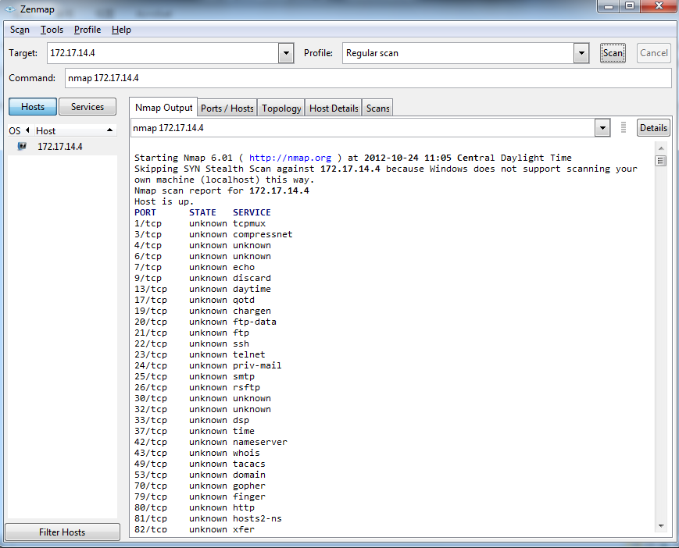
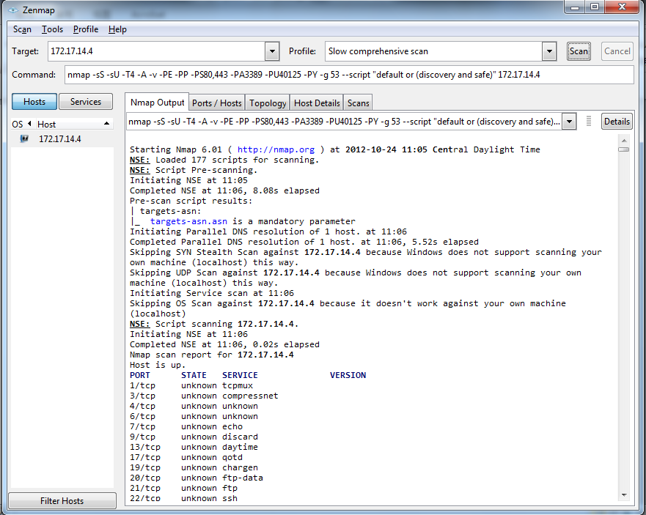

Result
We have learned how to use wireshark and nmap to capture the package when we initiate TCP or UDP, and we sniffered the password in FTP since it is not secure.
Nmap can scan the port of the source or the server.

Conclusion
We learned a lot from this lab and the two tools are very interesting and useful.
.

References
- Lab guides offered by Dr. Wu and the explanation of GTA Mr.Hou
- XAMPP website, http://www.apachefriends.org/en/xampp.html
- MySQL website, http://dev.mysql.com/doc/refman/5.5/en/index.html

